WEEK 6 – ADT List

Last Lecture

- Class
- Inheritance

Outline of Today’s Lecture

- ADT List
Abstract Data Type (ADT)

- A data type whose properties (domain and operations) are specified independently of any particular implementation.
Data from 3 different levels

- Application (or user) level: modeling real-life data in a specific context.

- Logical (or ADT) level: abstract view of the domain and operations. WHAT

- Implementation level: specific representation of the structure to hold the data items, and the coding for operations. HOW

4 Basic Kinds of ADT Operations

- Constructor -- creates a new instance (object) of an ADT.
- Transformer -- changes the state of one or more of the data values of an instance.
- Observer -- allows us to observe the state of one or more of the data values of an instance without changing them.
- Iterator -- allows us to process all the components in a data structure sequentially.
What is a List?

- A list is a homogeneous collection of elements, with a linear relationship between elements.

- That is, each list element (except the first) has a unique predecessor, and each element (except the last) has a unique successor.
Drawing of one-dimension
Sorted and Unsorted Lists
UNSORTED LIST

Elements are placed into the list in
no particular order.

SORTED LIST

List elements are in an order that is sorted in
some way -- either numerically or alphabetically by the elements themselves, or by a component of the element (called a KEY member) .

ADT Unsorted List Operations
change state

observe state

process all
Transformers
- MakeEmpty
- InsertItem
- DeleteItem
Observers
- IsFull
- LengthIs
- RetrieveItem

Iterators
- ResetList
- GetNextItem

What is a Generic Data Type?

A generic data type is a type for which the operations are defined but the types of the items being manipulated are not defined.

One way to simulate such a type for our UnsortedList ADT is via a user-defined class ItemType with member function ComparedTo having enumerated type value LESS, GREATER, or EQUAL.
// SPECIFICATION FILE ( unsorted.h )
#include “ItemType.h”
class UnsortedType // declares a class data type
{
public : // 8 public member functions

void MakeEmpty ( ) ;
bool IsFull ( ) const ;
int LengthIs ( ) const ; // returns length of list
void RetrieveItem ( ItemType& item, bool& found ) ;
void InsertItem ( ItemType item ) ;
void DeleteItem ( ItemType item ) ;
void ResetList ( );
void GetNextItem ( ItemType& item ) ;
private : // 3 private data members
int length ;
ItemType info[MAX_ITEMS] ;
int currentPos ;
} ;
Class Interface Diagram
UnsortedType class
Private data:

length

info [ 0 ]
[ 1 ]
[ 2 ]

[MAX_ITEMS-1]

currentPos

IsFull
LengthIs
ResetList
DeleteItem
InsertItem
MakeEmpty
RetrieveItem
GetNextItem
// IMPLEMENTATION FILE ARRAY-BASED LIST ( unsorted.cpp )
#include “itemtype.h”

void UnsortedType::MakeEmpty ( )
// Pre: None.
// Post: List is empty.
{
length = 0 ;
}

void UnsortedType::InsertItem ( ItemType item )
// Pre: List has been initialized. List is not full. item is not in list.
// Post: item is in the list.
{
info[length] = item ;
length++ ;
}

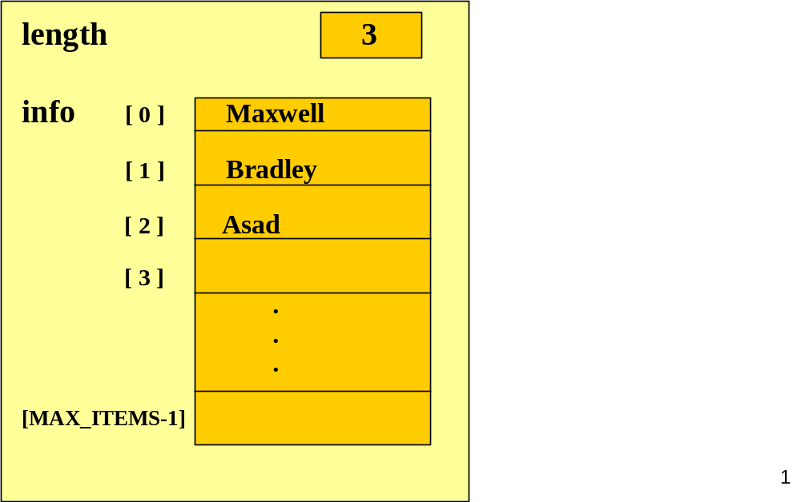
Before Inserting Hsing into an
Unsorted List
The item will
be placed into
the length location,
and length will be
incremented.
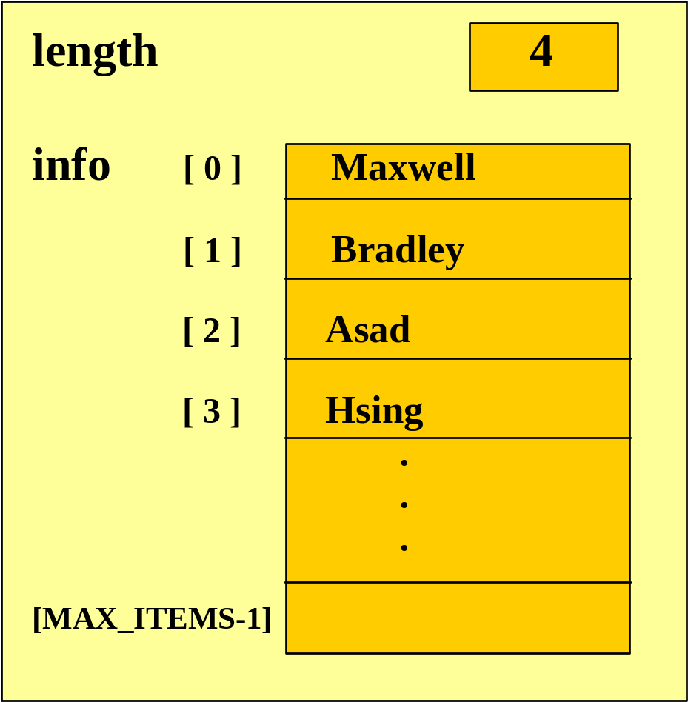
After Inserting Hsing into an
Unsorted List
void UnsortedType::LengthIs ( ) const
// Pre: List has been inititalized.
// Post: Function value == ( number of elements in list ).
{
return length ;
}

?

bool UnsortedType::IsFull ( ) const
// Pre: List has been initialized.
// Post: Function value == ( list is full ).
{
return ( length == MAX_ITEMS ) ;
}
void UnsortedType::RetrieveItem ( ItemType& item, bool& found )
// Pre: Key member of item is initialized.
// Post: If found, item’s key matches an element’s key in the list and a copy
// of that element has been stored in item; otherwise, item is unchanged.
{ bool moreToSearch ;
int location = 0 ;

found = false ;
moreToSearch = ( location < length ) ;
while ( moreToSearch && !found )
{
switch ( item.ComparedTo( info[location] ) )
{ case LESS :
case GREATER : location++ ;
moreToSearch = ( location < length ) ;
case EQUAL : found = true ;
item = info[ location ] ;
break ;
}
}
}
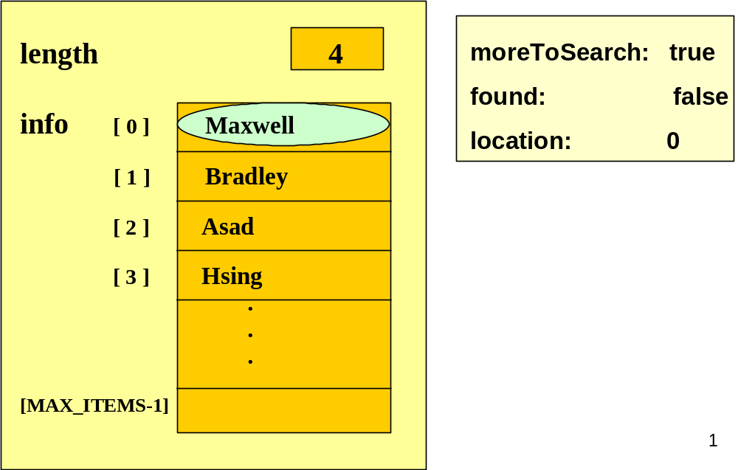
Retrieving Ivan from an
Unsorted List
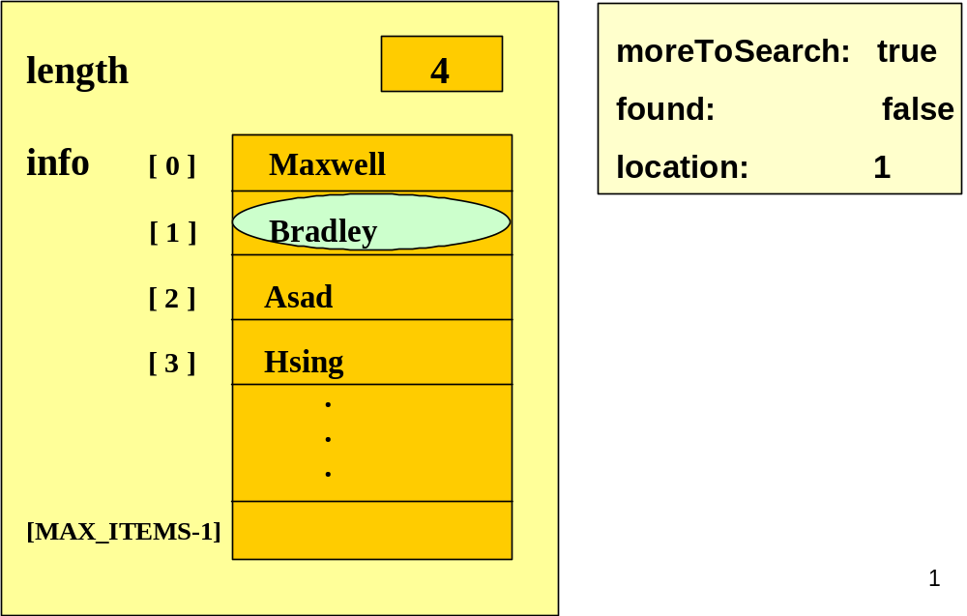
Retrieving Ivan from an
Unsorted List
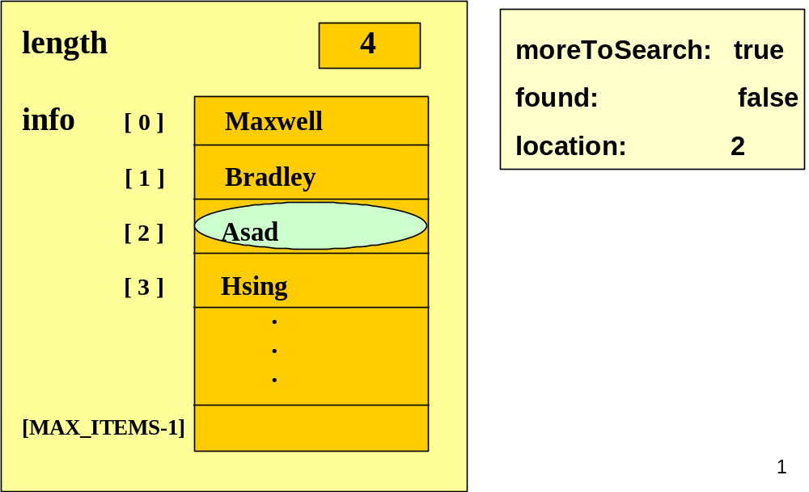
Retrieving Ivan from an
Unsorted List
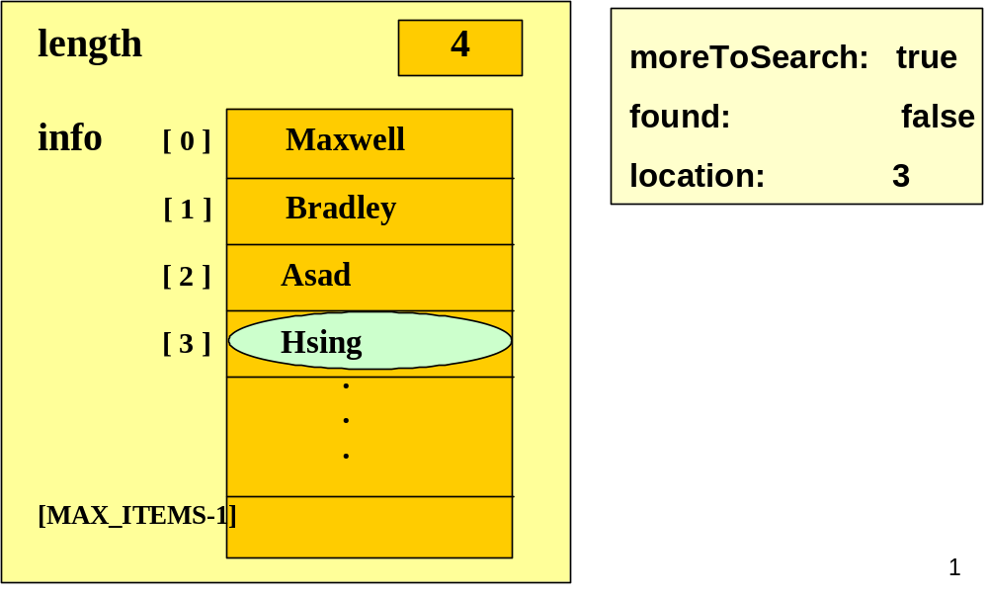
Retrieving Ivan from an
Unsorted List
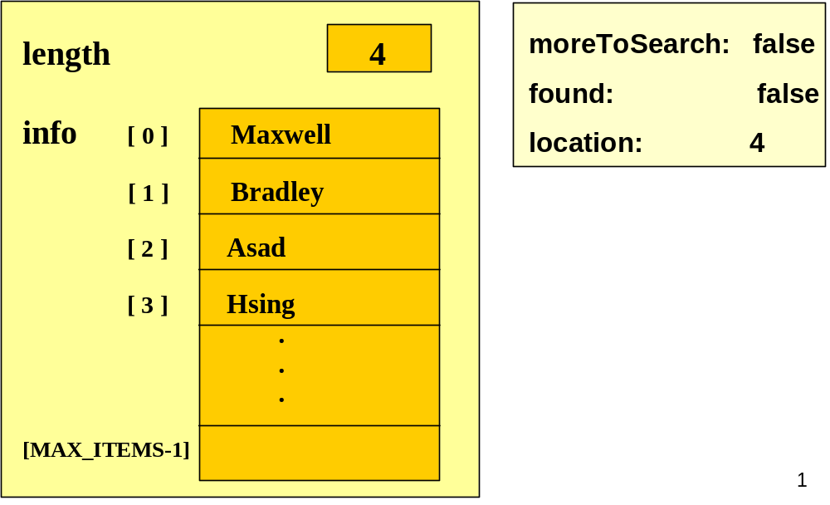
Retrieving Ivan from an
Unsorted List
void UnsortedType::DeleteItem ( ItemType item )
// Pre: item’s key has been inititalized.
// An element in the list has a key that matches item’s.
// Post: No element in the list has a key that matches item’s.
{
int location = 0 ;

while (item.ComparedTo (info [location] ) != EQUAL )
location++;

// move last element into position where item was located

info [location] = info [length - 1 ] ;
length-- ;
}
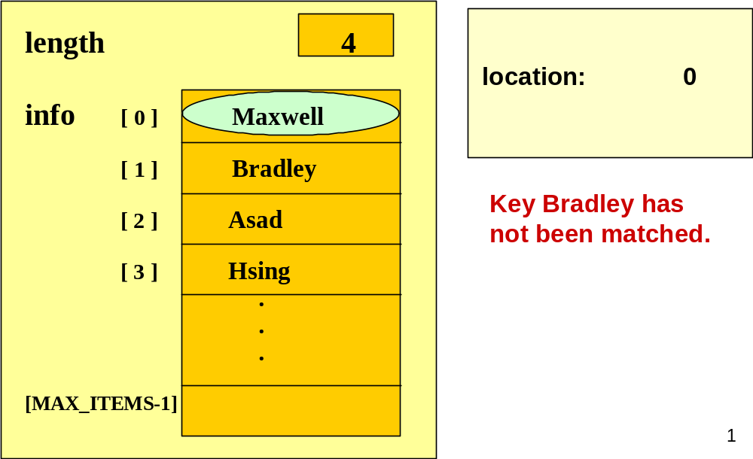
Deleting Bradley from an
Unsorted List
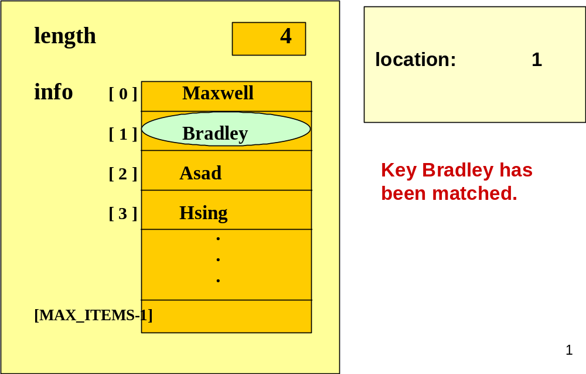
Deleting Bradley from an
Unsorted List
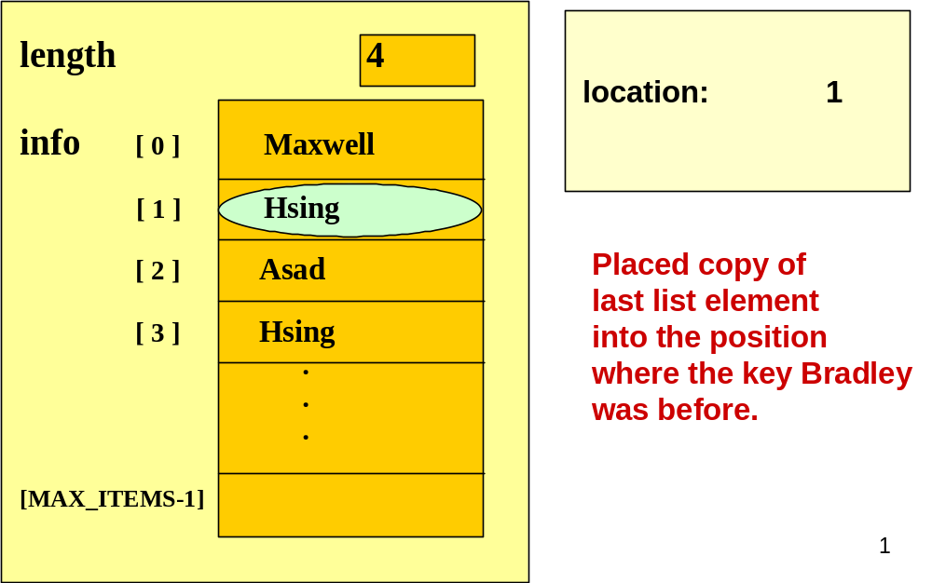
Deleting Bradley from an
Unsorted List
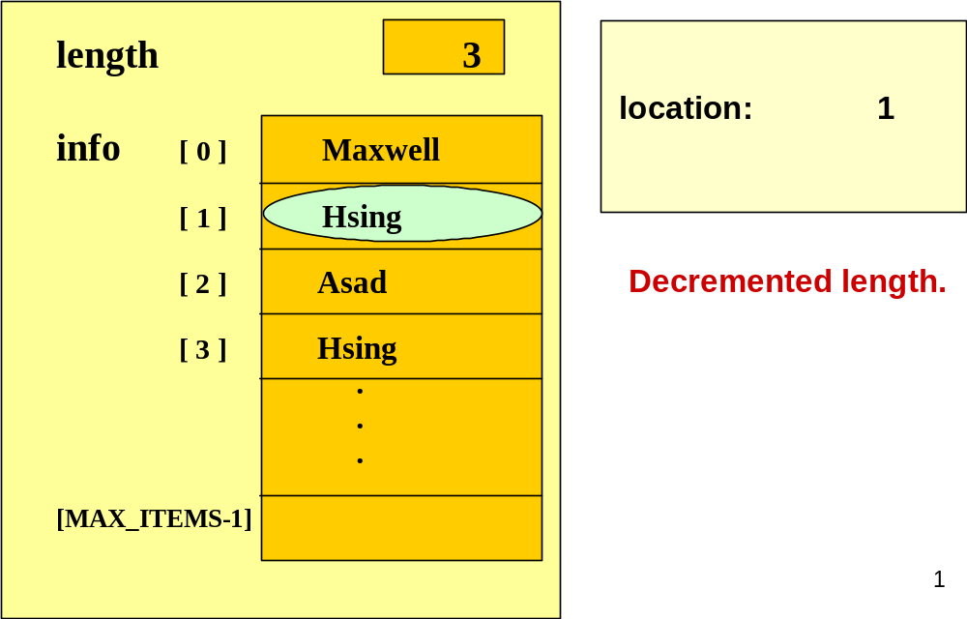
Deleting Bradley from an
Unsorted List
void UnsortedType::ResetList ( )
// Pre: List has been inititalized.
// Post: Current position is prior to first element in list.
{
currentPos = -1 ;
}

void UnsortedType::GetNextItem ( ItemType& item )
// Pre: List has been initialized. Current position is defined.
// Element at current position is not last in list.
// Post: Current position is updated to next position.
// item is a copy of element at current position.
{
currentPos++ ;
item = info [currentPos] ;
}
Specifying class ItemType

// SPECIFICATION FILE ( itemtype.h )

const int MAX_ITEM = 5 ;
enum RelationType { LESS, EQUAL, GREATER } ;

class ItemType // declares class data type
{
public : // 3 public member functions
RelationType ComparedTo ( ItemType ) const ;
void Print ( ) const ;
void Initialize ( int number ) ;

private : // 1 private data member
int value ; // could be any different type
} ;
// IMPLEMENTATION FILE ( itemtype.cpp )
// Implementation depends on the data type of value.
#include “itemtype.h”
#include <iostream>
using namespace std;
RelationType ComparedTo ( ItemType otherItem ) const
{
if ( value < otherItem.value )
return LESS ;
else if ( value > otherItem.value )
return GREATER ;
else return EQUAL ;
}
void Print ( ) const
{
cout << value << endl ;
}
void Initialize ( int number )
{ value = number ;
}
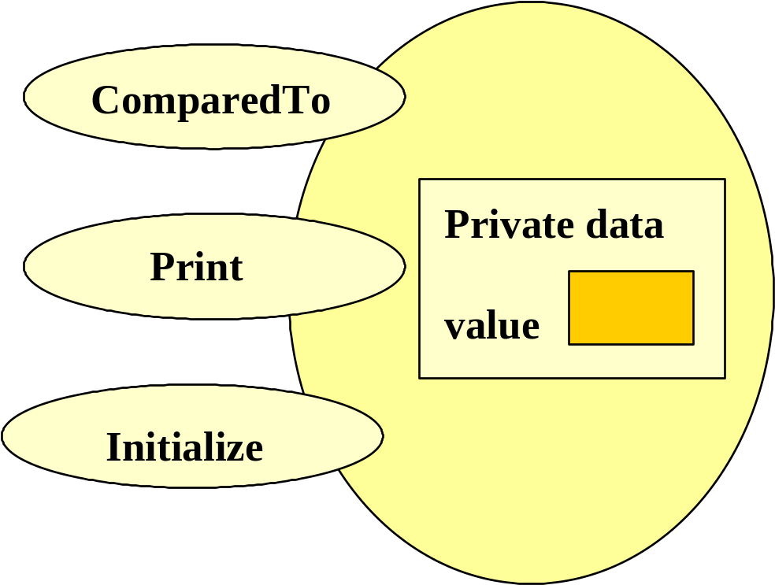
ItemType
Class Interface Diagram
Lecture 2 of Week 6

Outline of Today’s Lecture

- ADT Sorted List
- ADT Stack

Fig. 1
Sorted Type Class Interface Diagram
?
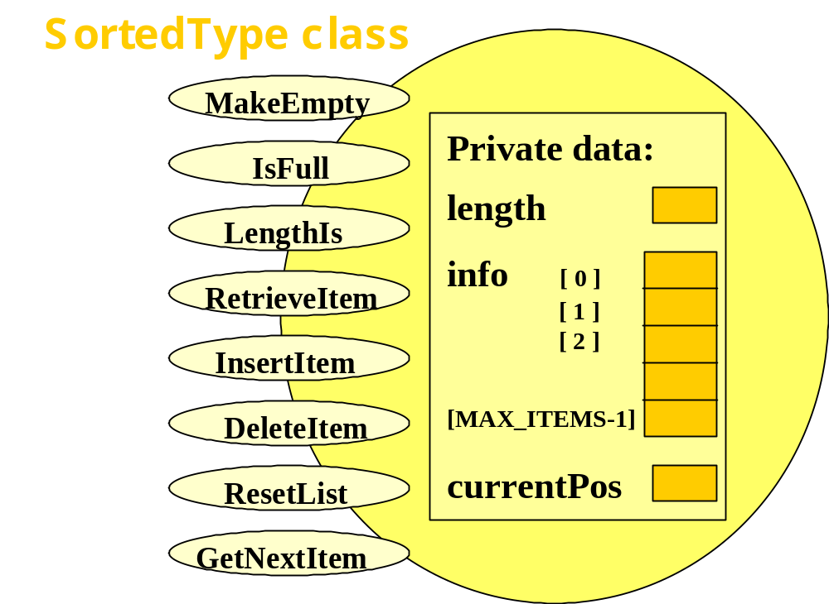
Member functions

Which member function specifications and implementations must change to ensure that any instance of the Sorted List ADT remains sorted at all times?

- InsertItem

- DeleteItem

?

InsertItem algorithm for
SortedList ADT
- Find proper location for the new element in the sorted list.

- Create space for the new element by moving down all the list elements that will follow it.

- Put the new element in the list.

- Increment length.
Implementing SortedType
member function InsertItem

// IMPLEMENTATION FILE (sorted.cpp)

#include “itemtype.h” // also must appear in client code (?)

void SortedType :: InsertItem ( ItemType item )
// Pre: List has been initialized. List is not full. item is not in list.
// List is sorted by key member using function ComparedTo.
// Post: item is in the list. List is still sorted.
{
.
.
.

}
void SortedType :: InsertItem ( ItemType item )
{ bool moreToSearch ;
int location = 0 ;
// find proper location for new element
moreToSearch = ( location < length ) ;
while ( moreToSearch )
{ switch ( item.ComparedTo( info[location] ) )
{ case LESS : moreToSearch = false ;
break ;
case GREATER : location++ ;
moreToSearch = ( location < length ) ;
break ;
}
} // make room for new element in sorted list
for ( int index = length ; index > location ; index-- )
info [ index ] = info [ index - 1 ] ;
info [ location ] = item ;
length++ ;
} ?
DeleteItem algorithm for
SortedList ADT

- Find the location of the element to be deleted from the sorted list.

- Eliminate space occupied by the item being deleted by moving up all the list elements that follow it.

- Decrement length.

Implementing SortedType
member function DeleteItem

// IMPLEMENTATION FILE continued (sorted.cpp)

void SortedType :: DeleteItem ( ItemType item )
// Pre: List has been initialized. Key member of item is initialized.
// Exactly one element in list has a key matching item’s key.
// List is sorted by key member using function ComparedTo.
// Post: No item in list has key matching item’s key.
// List is still sorted.
{
.
.
.

}
void SortedType :: DeleteItem ( ItemType item )
{
int location = 0 ;
// find location of element to be deleted

while ( item.ComparedTo ( info[location] ) != EQUAL )
location++ ;

// move up elements that follow deleted item in sorted list

for ( int index = location + 1 ; index < length ; index++ )
info [ index - 1 ] = info [ index ] ;

length-- ;
}

Improving member function RetrieveItem
Recall that with the Unsorted List ADT
we examined each list element beginning
with info[ 0 ], until we either found a
matching key, or we had examined all
the elements in the Unsorted List.

How can the searching algorithm be improved for Sorted List ADT?

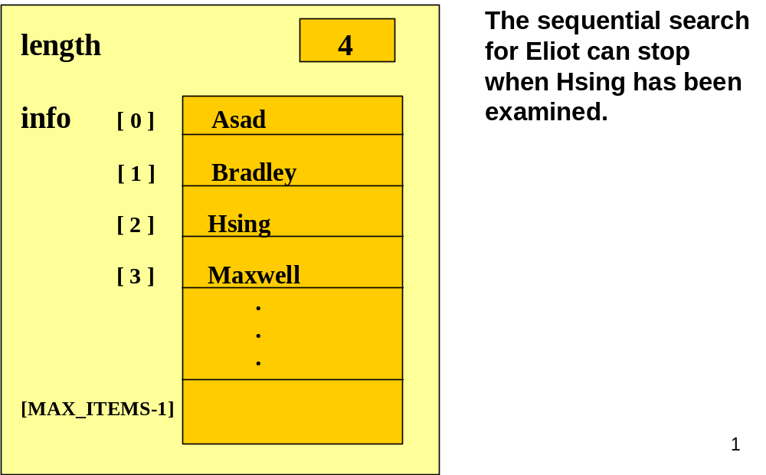
Retrieving Eliot from a
Sorted List
Binary Seach in a Sorted List

- Examines the element in the middle of the array. Is it the sought item? If so, stop searching. Is the middle element too small? Then start looking in second half of array. Is the middle element too large? Then begin looking in first half of the array.

- Repeat the process in the half of the list that should be examined next.

- Stop when item is found, or when there is nowhere else to look and item has not been found.
?

void SortedType::RetrieveItem ( ItemType& item, bool& found )
// Pre: Key member of item is initialized.
// Post: If found, item’s key matches an element’s key in the list and a copy
// of that element has been stored in item; otherwise, item is unchanged.
{ int midPoint ;
int first = 0;
int last = length - 1 ;
bool moreToSearch = ( first <= last ) ;

found = false ;
while ( moreToSearch && !found )
{ midPoint = ( first + last ) / 2 ; // INDEX OF MIDDLE ELEMENT
switch ( item.ComparedTo( info [ midPoint ] ) )
{
case LESS : . . . // LOOK IN FIRST HALF NEXT
case GREATER : . . . // LOOK IN SECOND HALF NEXT
case EQUAL : . . . // ITEM HAS BEEN FOUND
}
}
}

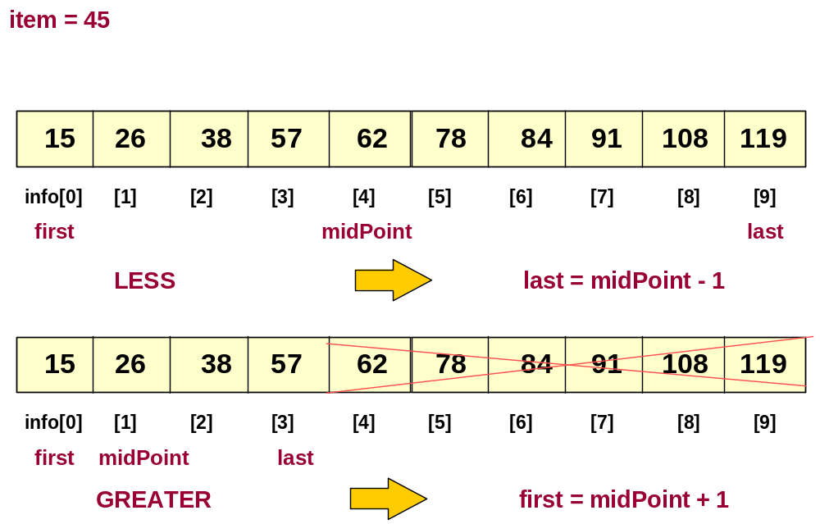
Trace of Binary Search
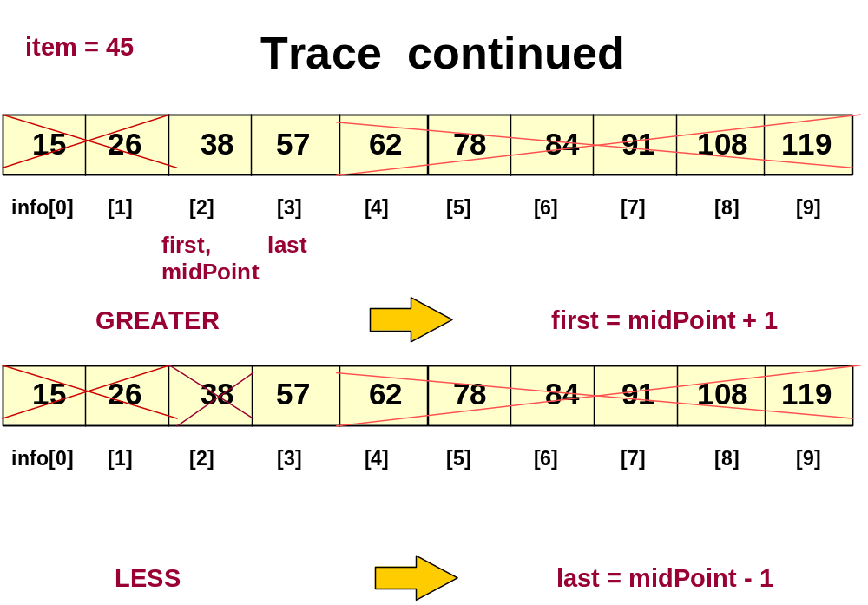
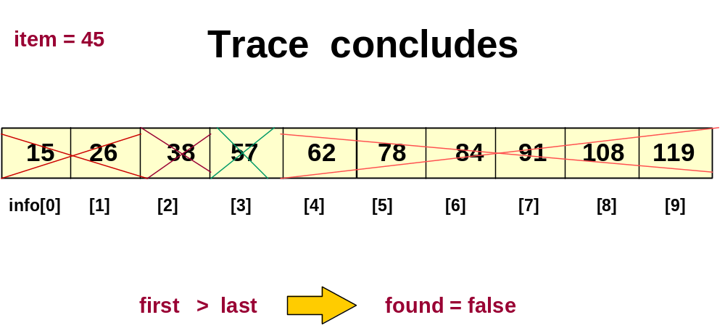

void SortedType::RetrieveItem ( ItemType& item, bool& found )
// ASSUMES info ARRAY SORTED IN ASCENDING ORDER
{ int midPoint ;
int first = 0;
int last = length - 1 ;
bool moreToSearch = ( first <= last ) ;
found = false ;

while ( moreToSearch && !found )
{ midPoint = ( first + last ) / 2 ;
switch ( item.ComparedTo( info [ midPoint ] ) )
{ case LESS : last = midPoint - 1 ;
moreToSearch = ( first <= last ) ;
break ;
case GREATER : first = midPoint + 1 ;
moreToSearch = ( first <= last ) ;
break ;
case EQUAL : found = true ;
item = info[ midPoint ] ;
break ;
}
}
}
Order of Magnitude of a Function

The order of magnitude, or Big-O notation,
of a function expresses the computing time
of a problem as the term in a function that
increases most rapidly relative to the size
of a problem.

Names of Orders of Magnitude

O(1) bounded (by a constant) time
O(log₂N) logarithmic time
O(N) linear time
O(N*log₂N) N*log₂N time

O(N²) quadratic time

O( 2^{N} ) exponential time
Fig .2
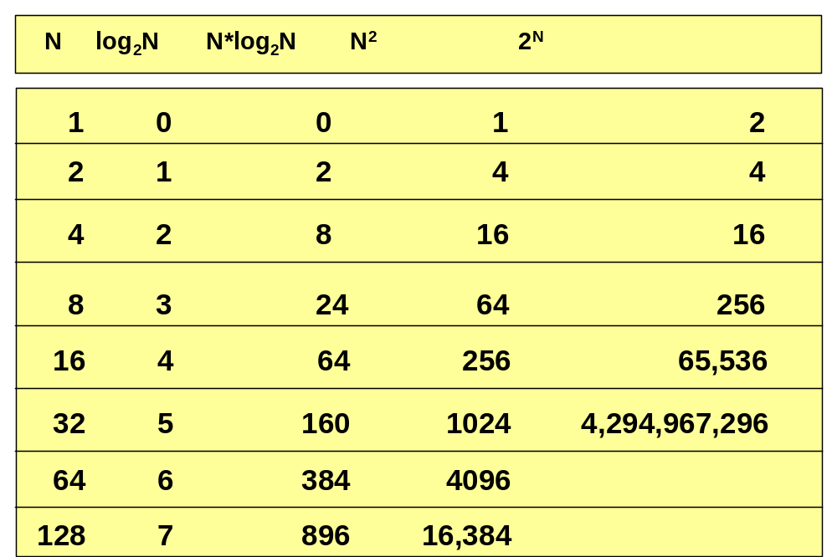
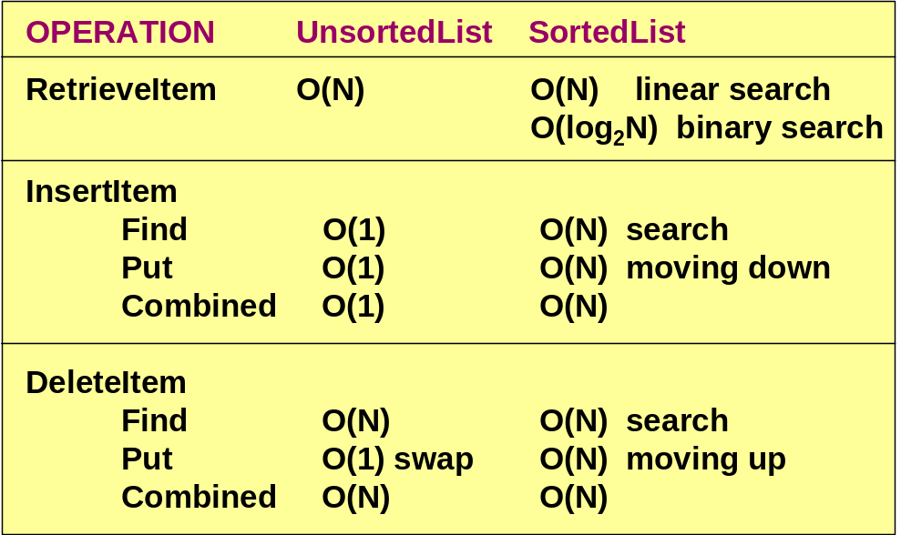
Big-O Comparison of List Operations (?)
Summary about ADT & List

- What are ADT and its 4 Operations ?
- What are list and unsorted list ?
- How are its operations working ?
- What is sorted list ?
- How are its operations working ?
- What is the binary search ?
- What is Big-O notation ?
- What are the Big-Os of operations of unsorted and sorted lists ?

Today’s Lecture

- ADT List & Stack

Next Lecture

- Recursion

